Binario | Decimal | Hexadecimal
0101 0000 | 80 | 50
0111 1000 | 120 | 78
0011 1101 | 61 | 3D
1101 | 13 | D
1001 0110 | 150 | 96
0101 0010 0101 | 2597 | A25
1011 1111 0011 0000 0101 1010 | 12529754 | BF305A

1B) 0101 0000 = 2⁴ + 2⁶ = 80 1C) 0101 = 5 - 0000 = 0 = 50
2A) 7 = 0111 8 = 1000 2C) 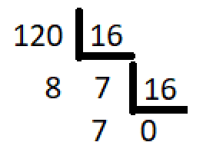

3A) 3 = 0011 D=1101 3D= 00111101 3B) 3.16¹ + 13.16⁰ = 61
4A) 1101 = D 4C) 13.16⁰ = 13
5A) 1001 6 = 0110 96 = 1001 0110 5B) 9 . 16¹ + 6 . 16⁰ = 150
6B) 10.16² + 2.16¹ + 5.16⁰ = 2597 6C) 10 = 1010 2 = 0010 5 = 0101 = A25

7B) 11.16⁵ + 15.16⁴ + 3.16³ + 5.16¹ + 10.16⁰ = 12529754
7A) 1011 = B 1111 = F 0011 = 3 0000 = 0 0101 = 5 1010 = A = BF305A

2)
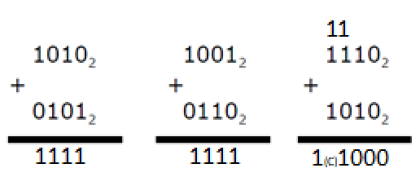
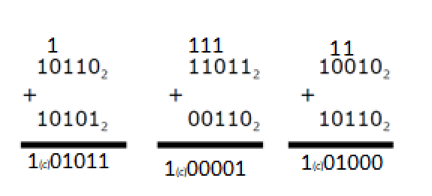
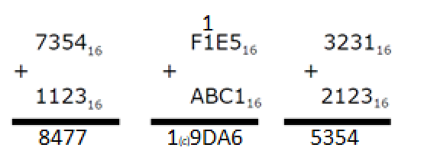

3)
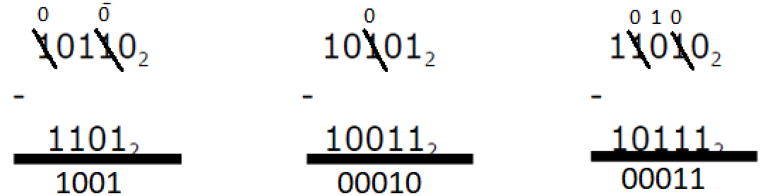
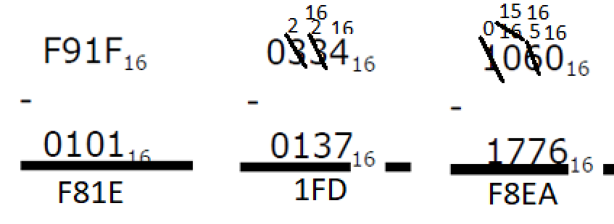

4)
 | BINARIO | SYM | COM1 | COM2
000 | 0 | +0 | +0 | 0
001 | 1 | +1 | +1 | +1
010 | 2 | +2 | +2 | +2
011 | 3 | +3 | +3 | +3
100 | 4 | -0 | -3 | -4
101 | 5 | -1 | -2 | -3
110 | 6 | -2 | -1 | -2
111 | 7 | -3 | -0 | -1

5)
 | BINARIO | SYM | COM1 | COM2
0000 | 0 | +0 | +0 | +0
0001 | 1 | 1 | 1 | 1
0010 | 2 | 2 | 2 | 2
0011 | 3 | 3 | 3 | 3
0100 | 4 | 4 | 4 | 4
0101 | 5 | 5 | 5 | 5
0110 | 6 | 6 | 6 | 6
0111 | 7 | 7 | 7 | 7
1000 | 8 | -0 | -7 | -8
1001 | 9 | -1 | -6 | -7
1010 | 10 | -2 | -5 | -6
1011 | 11 | -3 | -4 | -5
1100 | 12 | -4 | -3 | -4
1101 | 13 | -5 | -2 | -3
1110 | 14 | -6 | -1 | -2
1111 | 15 | -7 | -0 | -1

